Introduction to ComputING

Section G

Exercises 6 – PRACTICE QUESTIONS

dECEMBER 2014

QUESTION 1

What is the output of the following piece of code?

const int SIZE = 30;

void main()

{

char str1[SIZE]="\0";

char str2[SIZE]="\0";

char str3[SIZE] = "\0";

int i;

for (i=0;i<'9'-'0'+1;++i)

str1[i] = '9' - i;

cout << str1 << '\n';

for (i=0;i<'9'-'0'+1;++i)

str2[i] = '0' + i;

cout << str2 << '\n';

for (i=0;i<strlen(str1)+strlen(str2);i=i+2)

{ str3[i] = str1[i];

str3[i+1] = str2[i];

}

cout << str3 << '\n';

}

**SOLUTION**

9876543210

0123456789

9072543618

**QUESTION 2**

What is the output of this piece of code:

const int COL = 5;

void processArray(int arr[][COL],int rows)

{

int a=0,i,j;

for (i=0;i<rows;++i)

{

a = 0;

for (j=0;j<COL;++j)

{

a = a+ arr[i][j];

arr[i][j] = a;

}

}

}

void fillArray(int arr[][COL], int rows)

{

int i,j;

for (i=0;i<rows;++i)

{ for (j=0;j<COL;++j)

{

arr[i][j] = i+j*rows;

}

}

}

void printArray(int arr[][COL], int rows)

{

int i,j;

for (i=0;i<rows;++i)

{ for (j=0;j<COL;++j)

{

cout << arr[i][j] << " ";

}

cout << "\n";

}

}

|  |  |
| --- | --- |
| int main()  {  const int ROWS=4;  int arr[4][COL];  fillArray(arr,ROWS);  printArray(arr,ROWS);  processArray(arr,ROWS);  printArray(arr,ROWS);  } | **SOLUTION**  0 4 8 12 16  1 5 9 13 17  2 6 10 14 18  3 7 11 15 19  0 4 12 24 40  1 6 15 28 45  2 8 18 32 50  3 10 21 36 55 |

QUESTION 3

Write a function that swaps the first and the last elements of chunks in an array. For an array consisting of 9 elements and assuming a chunk of size 3:

Array elements: 1 2 3 4 5 6 7 8 9

The output would be, 3 2 1 6 5 4 9 8 7

Inverting here means swapping the last and the first element of a chunk.

QUESTION 4

Write a function to implement the following: Given an array of integers, rotate each half of the array in opposite directions. The function takes the following parameters:

|  |  |  |
| --- | --- | --- |
| 1. | Direction of rotation (both halves in opposite directions) | 0 or 1 |
| 2. | Number of times the arry should be rotated | Any positive integer |
| 3. | Array which is to be rotated |  |

For example:

int myarr[8]={ 1111, 1222, 1333, 1444, 1555, 1666, 1777, 1888};

If number of rotations = 1 & direction of rotation = 0

myarray: **1222, 1333, 1444, 1111,** 1888, 1555, 1666, 1777

If number of rotations = 1 & direction of rotation = 1

myarray: 1444, 1111, 1222, 1333, 1666, 1777, 1888, 1555

Note: Your function should work for an array of any size. Also, it would be better that your array has an even number of elements. This way both halves would have the same number of elements to rotate.

QUESTION 5

Write functions to calculate the average of a specific row and a specific column.

float avg2DrowWise(int arr[][col], int row, int col, int rowNum)

float avg2DcolWise(int arr[][col], int row, int col, int colNum)

Also write a function that calculates the sum of all the elements of a 2D matrix.

int sum2Dmatrix(int arr[][col], int row, int col)

Now write a function print() that prints the 2-D matrix, the row average against the corresponding row, column average beneath the corresponding column and in the bottom right the sum of the 2-D matrix.

QUESTION 6

Write a program that prompts the users to enter 12 numbers. This program reads the numbers into an array. Make another array that will store the average of numbers.

The two arrays will be passed to a function for and the average will be calculated by

1. Take First Four Numbers at index calculate their average and store at first index in Average Array.
2. Next time skip the first index number and average the next 4 Index Numbers and store at second index in average array.
3. And this procedure will continue, until Average for all windows will be stored in Average Array.

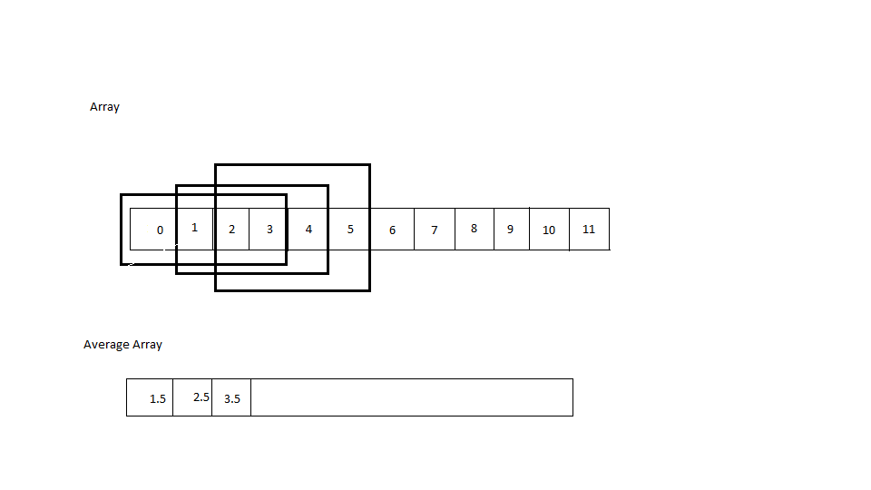

QUESTION 7

You have to write a C++ function “reverseWord” that reverses a word in a given string.

For example, if the string given to the function is, ”National University of Computer and Emerging Sciences”, and the word to reverse is “Computer”, the original string would be changed to, “National University of retupmoC and Emerging Sciences”